Blood Pressure and Circulatory Lab Investigation

Richard Armacinski

Intermediate/Senior Division

Brock University

Course: SBI 3U
Time 90 Minutes

Overall Expectations
E2. investigate, through laboratory inquiry or computer simulation, the functional responses of the respiratory and circulatory systems of animals, and the relationships between their respiratory, circulatory, and digestive systems;

E3. demonstrate an understanding of animal anatomy and physiology, and describe disorders of the respiratory, circulatory, and digestive systems;

A1. Demonstrate scientific investigation skills (related to both inquiry and research) in the four areas of skills (initiating and planning, performing and recording, analyzing and interpreting, and communicating).
Specific Expectations
E2.1 use appropriate terminology related to animal anatomy, including, but not limited to: systolic, diastolic, diffusion gradient, inhalation, exhalation, coronary, cardiac, ulcer, asthma, and constipation [C]

E2.3 use medical equipment (e.g., a stethoscope, a sphygmomanometer) to monitor the functional responses of the respiratory and circulatory systems to external stimuli (e.g., measure the change in breathing rate and heart rate after exercise) [PR, AI].

E3.4 describe some disorders related to the respiratory, digestive, and circulatory systems (e.g., asthma, emphysema, ulcers, colitis, cardiac arrest, arteriosclerosis)

A1.5 conduct inquiries, controlling relevant variables, adapting or extending procedures as required, and using appropriate materials and equipment safely, accurately, and effectively, to collect observations and data;

A1.6 compile accurate data from laboratory and other sources, and organize and record the data, using appropriate formats, including tables, flow charts, graphs, and/or diagrams;

A1.8 synthesize, analyse, interpret, and evaluate qualitative and/or quantitative data to determine whether the evidence supports or refutes the initial predictions or hypothesis and whether it is consistent with scientific theory; identify sources of bias and/or error; and suggest improvements to the inquiry to reduce the likelihood of error;

A1.11 communicate ideas, plans, procedures, results, and conclusions orally, in writing, and/or in electronic presentations, using appropriate language and a variety of formats (e.g., data tables, laboratory reports, presentations, debates, simulations, models)
Lesson Learning Goals
Knowledge & Understanding, Thinking, Communication, Application
Describe in student-friendly language the curriculum expectations where applicable.
At the end of this lesson, students will know, understand and/or be able to:
- Evaluate the importance of cardiac technologies, specifically the angioplasty procedure, to improve the lifestyle of individuals.
- Use appropriate terminology when explaining blood pressure and understand how the readings work.
- Use a sphygmomanometer to monitor the change in heart rate before and after exercise.
- Describe that arteriosclerosis is the buildup of plaque in the lining of the arteries.
Learning Skills and Work Habits
Responsibility, Independent Work, Organization, Collaboration, Initiative, Self-Regulation
Describe in student-friendly language the learning skills and work habits where applicable. Growing Success, p 10 & 11
Responsibility – students need to take notes and fill in the worksheets within their packages. They will need to answer questions and as for clarification when concepts are not clear.
Organization – students need to be organized in their approach and have their notes ready to be filled in during the lesson. After the lesson, they will have to pull out their lab worksheets and be prepared to move into the dance studio to continue with their work.
Collaboration – students will have to work in groups to measure blood pressure changes. They will need to work as a team and divide tasks diligently.

Assessment and Evaluation
How will I know when my students are successful?
Assessment Task/Strategy: What evidence (observation, product, conversations) will I collect to know my students are successful?  Identify and describe what students will be doing to address the learning goals for this lesson. | - Assessment For Learning  - Diagnostic  - Formative  - Assessment As Learning  - Formative  - Assessment Of Learning  - Summative | Assessment tools:  Identify and describe the tool that will be used to record the information for the assessment task, and use to help analyze what students are able to do against the established success criteria. (Anecdotal Record, Rating Scale, Checklist, Rubric, etc)
- Explain the concept of blood pressure  - Show how pressure is sustained in arteries  - Describe the difference between systole and diastole  - Show students how to take blood pressure  - Explain what hypertension is and the blood vessels can be fixed through angioplasty  - Review key concepts  - Go through what students will be doing in the lab  -Allow students to take blood pressure and interpret the meaning of this  Success criteria:  I know I will be successful when I can:  - Explain the angioplasty surgery and how it is medically performed  - Describe what blood pressure means and how it is important to the health of individuals  - Understand how to use a blood pressure cuff to measure my blood pressure  - Describe arteriosclerosis and hypertension and what can be done to help the cause | Assessment as learning  - Students can think about their learning throughout the lesson and come up with questions for concepts that they are having difficulty understanding. At the end of the class, they will be asked a couple questions about the lesson, and if they have trouble answering some questions they can think about the answers and think about what they have to do in order to better understand the concepts.  Assessment for learning  - Teacher takes notes of students answering questions during the lesson. If they understand a concept easily, time will not have to be spent on it. If there is difficulty answering questions across the room, concepts can be revisited. Questions at the end of the class; teacher can see where students are struggling and revisit concepts the next day at the beginning of class with a review.  Assessment of learning  - Students will demonstrate their understanding of the lesson through a laboratory. They will perform a series of tasks and will have to answer questions based on what they know and investigate what they need to know. | - Anecdotal record - have a list of the student names at the front of the class. Ask students questions throughout the lesson. Let them discuss with a partner and then select a few random students. Take notes of their understanding. If there is trouble with a concept from a few students, then mark this down and make sure to go over it either at the end of the lesson or come back to it tomorrow.  - Questions at the end of the class -review material covered in the lesson and ask students to respond to questions.  - Walk around the room during the lab and make sure that students are on task and working diligently. If they have questions, be sure to steer them in the right direction and clarify any concepts if they are having trouble understanding.
Prior Learning
Prior to this lesson, students will be able to…
- Explain the key structures of the circulatory system
- Explain how blood flows through the heart and makes its way around the body
- Describe why blood pressure is greater in arteries than in veins
- Analyze the cycle of blood flow and understand how oxygen and carbon dioxide are exchanged throughout the body
Differentiated Instruction Responses
What will I do to assist and/or differentiate instruction for individual learners? Differentiation: Geography - Differentiation: Mathematics
Learning Materials (Content)
- The slide show will be a good visual aid for learners to take notes
- YouTube videos will be helpful for auditory learners to see explanations of the digestive system from another perspective
- This will cover various multiple intelligences
- The teacher can observe his or her learners and ask questions to students
- Those students that are having trouble understanding the content will be asked to remember the details of the lesson (ie, what is the normal reading for blood pressure?)
- Those that have mastered the skills can be given problem scenarios and apply their learning (ex. If a patient is experiencing chest pains or trouble breathing, they may require an angioplasty. Describe this procedure)
- The PowerPoint provides a good summary of the lesson
Ways of Learning (Process)
- Learners will have a stationary lesson, will have diagrams to give them a visual aid
- Visual and word learners can use the Nelson textbook for further clarification of concepts
- Auditory learners will have had the video clip to understand the content
Ways of Demonstrating Learning (Product)
- The sheet to be filled out during the lesson will be beneficial for logical thinkers as it is structured and follows a specific sequence
- If students have a hard time expressing their thoughts on paper, they will be able to orally present their answers to the teacher by answering questions
- The questions at the end of the lesson will consist of a general overview of the material covered in class. Students will be randomly selected to answer questions and they will be given time to discuss answers with their peers.
- The lab report will allow learners to put theory into practice.
- They will be able to demonstrate why heart rate and cardiac output increase during exercise.
Accommodations:  - Learners who have a hard time seeing can sit closer to the board  - Those that have a hard time hearing can sit closer to the board or an FM radio can be worn by the teacher if the student has a hearing aid  - Those that have a hard time writing can use a tablet to write answers and can use the tablet to take notes  - The video will help to visualize and hear from a different perspective if they have a hard time reading the text on slides  - Those that have a hard time reading instructions can work with a “designated reader”  - Celebrate the differences of students  - Bring examples of different cultures into play (ie. discoveries of scientists in anatomy around the world – a Russian scientist discovered the blood pressure cuff)  - Realize that all students have the ability to learn, but some need more support than others  - SpecEd. Learners should be able to have an accessible classroom and be seated in areas that will be easiest for them to see/move around with providing minimal distraction to the rest of the classroom. Student with ADHD is seated near the front of the room and teacher needs to try to keep them engaged and focused. |  | Modifications:  - For students with higher potential, they can be asked higher order thinking questions such as, “how do arteries accommodate for pressure difference in the vessels?”
Materials/Preparation/Safety Consideration(s) for Teaching
What do I need to prepare before I begin the lesson?
- Attendance sheet
- Handouts to fill out during the lesson
- PowerPoint slides
- YouTube videos:
- https://www.youtube.com/watch?v=qWti317qb_w
- https://www.youtube.com/watch?v=S9AqBd4RExk
- https://www.youtube.com/watch?v=KK_Aa4iej78
- Questions at the end of the lesson to test learning
- Anecdotal note sheet
- Circulatory Lab Investigation
- Dance room with video set up
- Make sure shoes are tied and that everyone is respectful and mindful of each other’s space in the dance studio.

Instructional Sequence
MINDS ON (10 minutes)  - Establishing a positive learning environment  - Connection to prior learning and/or experiences  - Setting the context for learning |  | Assessment Opportunities  Guiding Questions:  - What are you collecting?  (Observations/Conversations/Products)  - How are you collecting student data?  (Assessment tool)
- Start the class with a riddle to get minds going  - Ask students if they have any questions from yesterday’s homework  - Ask students if they need any further clarification on concepts - review  - Give the students an agenda for what is to come during the lesson  - Set learning goals and give the students a direction to head in |  | - Assessment as learning – students will prepare for what is to come after seeing the agenda and can start formulating questions and getting their mind in the correct frame of thought for the lesson.
ACTION (60 minutes)  - Introducing new learning or extending/reinforcing prior learning  - Providing opportunities for practice and application of learning (guided vs independent) |  | Assessment Opportunities
~~About 30 minutes (in-class lecture)  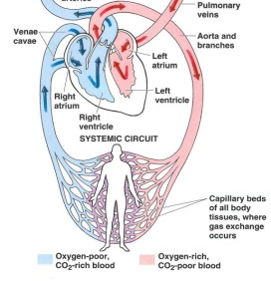  - Explain the concept of blood pressure and allow learners to see that pressure decreases as it moves away from the heart and makes its way back to the heart after circulating the body.  - Explain that the initial drop is the greatest, and then it becomes less steep.  - Explain how blood fills the heart in a relaxation phase and then contracts to release blood throughout the body.  - This concept was review in previous notes so ask students the question “what is the difference between systole and diastole?”  - Review the concepts of systole and diastole again to make sure learners understand the concept.  - Ask students why they think systolic pressure is greater than diastolic pressure – they should easily make the connection between pushing blood throughout the body being much greater than blood coming back into the heart.  - Explain the normal reading of blood pressure should be 120/80 – deviations may signal problems  - Show students a visual diagram of how blood pressure is taken and go through the diagram by breaking it apart step by step  - Give auditory and visual learners another way to see the concept of blood pressure by showing a short video clip:  - https://www.youtube.com/watch?v=qWti317qb_w  - Make a connection between the video and what has been learned in previous lessons about the importance of maintaining a healthy lifestyle  - Explain what hypertension is and what the blood pressure reading is seen as when this is the case: greater than 140/90  - Show learners a diagram of how arteries can become clogged, and this increases the pressure because blood has a smaller diameter to travel through the vessels  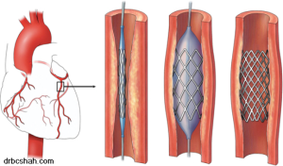  - Ask students how they think plaque is built up?  - Explain a procedure that can help fix the issue, being angioplasty  - Break apart the procedure in a step by step basis  - For visual and auditory learners, a video will be showed to see the procedure in real time.  - https://www.youtube.com/watch?v=S9AqBd4RExk  ~~ About 30 minutes (Go down to dance studio)  PART 2 LAB  - Go through the procedure of the circulatory lab investigation  - Explain the 2 parts of the lab  - Show students a video of how to measure their blood pressure  - https://www.youtube.com/watch?v=KK_Aa4iej78  During the lab:  - Start the lab with allowing students to take their pulse and blood pressure  - Play the Just Dance song to get heart rates up:  - https://www.youtube.com/watch?v=OobR681KUTo&t=0s&list=LLl01egLHvBb2VucoUo4COJA&index=3  - Allow students to retake their pulse and blood pressure  - They will note any differences  - Then let them check their cardio and stroke output and if time permits, they will be able to answer a series of questions found on the backside of the lab worksheet. |  | - Throughout the lesson, an anecdotal note-taking sheet can be used to mark down what students understand easily. Those concepts that are hard to grasp by students will be marked down and the teacher can revisit them with his or her students in the next lesson or at the review at the end of the lesson.  - Assessment for learning – ask students the question “what is the difference between systole and diastole?” – this makes sure the students are on track and if they cannot answer the question correctly, the teacher can review the concept  - Assessment as learning – at this point learners will realize that they need to pay attention to answer questions correctly. If they are struggling with the questions, then they will need to focus more or ask the teacher questions to clarify concepts  - Assessment as learning – learners will watch the video and have a review of the concepts of the lesson. If something is still unclear, they should ask for clarification because this has been a third time concepts have been explained.  - Assessment for learning – the teacher asks how they think plaque can build up in the arteries. The teacher sees if his or her students can make this application of their learning. They can see if they know that eating fatty foods and those high in cholesterol can be detrimental to health.  - Assessment for learning – teacher will walk around the room during the lab and help direct students. If they need help with taking blood pressure, they will show them how to follow the correct procedure. They will also ask questions such as “what do you think will happen to heart rate and blood pressure and cardiac output after exercise” to see what they know and ask them higher order thinking questions such as “will this increase or decrease the pH of the blood” and “what energy stores will be used up first to help accommodate for these changes?”  - Assessment as learning – students will see what they know from previous chapters and see if they can make the connection. If they have a hard time remembering, they will know that these are concepts that they will have to review for their unit test.  - Assessment of learning – teacher will collect the lab tomorrow and see the responses students came up with. They will see if any concepts need further clarification or if the students are on the right track.
CONSOLIDATION AND CONNECTION (5 minutes)  - Helping students demonstrate what they have learned  - Providing opportunities for consolidation and reflection |  | Assessment Opportunities
- End the in-class lecture with a series of questions, testing how good students understood the concepts of the lesson  - Allow learners to collaborate with peers in answering the questions and coming up with solutions to the problems  - Ask learners if they have any other questions or concepts that need further clarification at the end of the period in the dance studio  - Assign the lab to be due tomorrow  - Tell them that the review for the unit test is on LMS |  | - Assessment for learning – teacher can ask students questions and see how they can respond to them. They get a grasp of how the learners felt about the lesson  - Assessment as learning – students can see if they understood the questions posed. They can see what they need to review more and what concepts they are confident with.

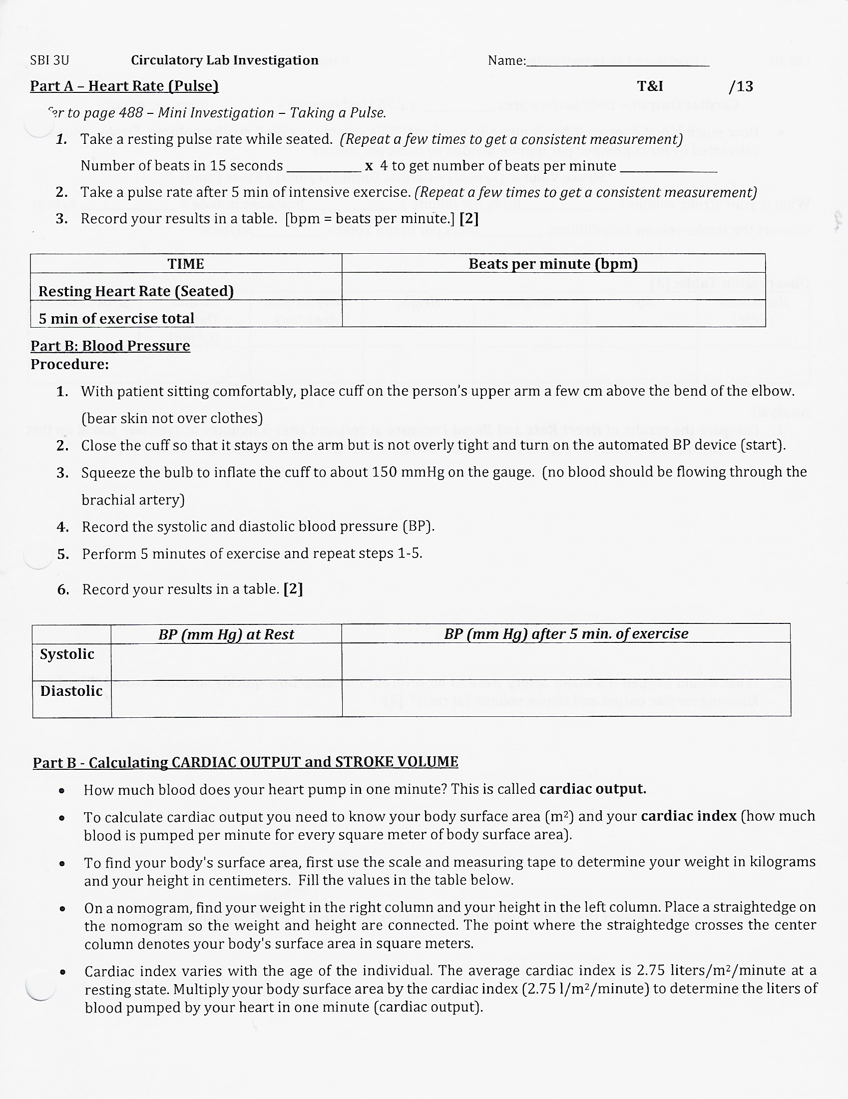
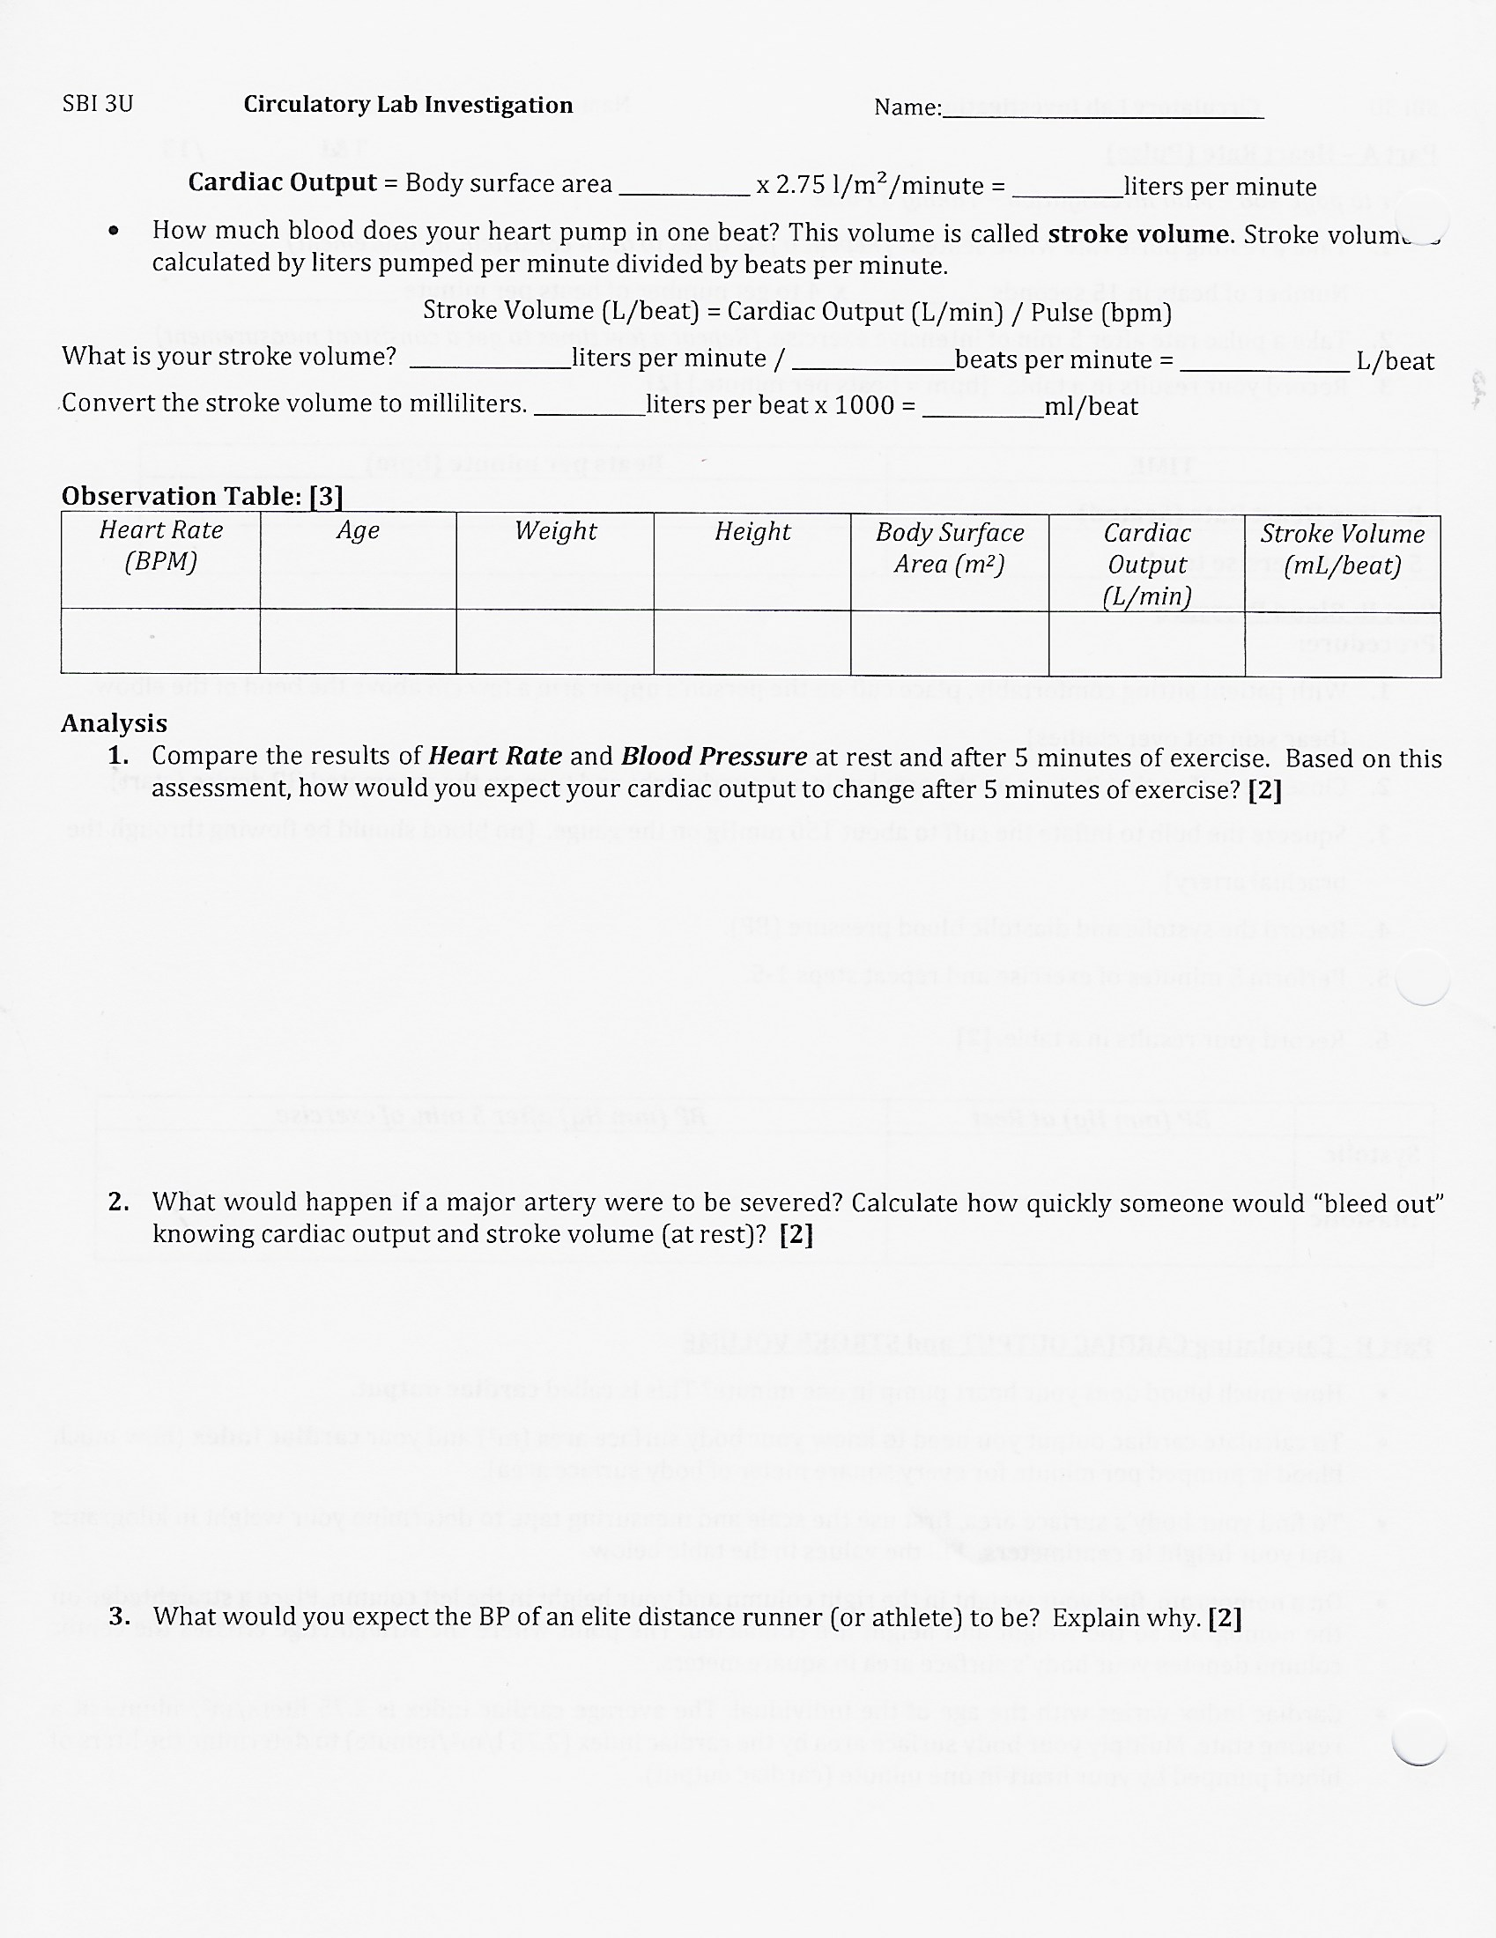
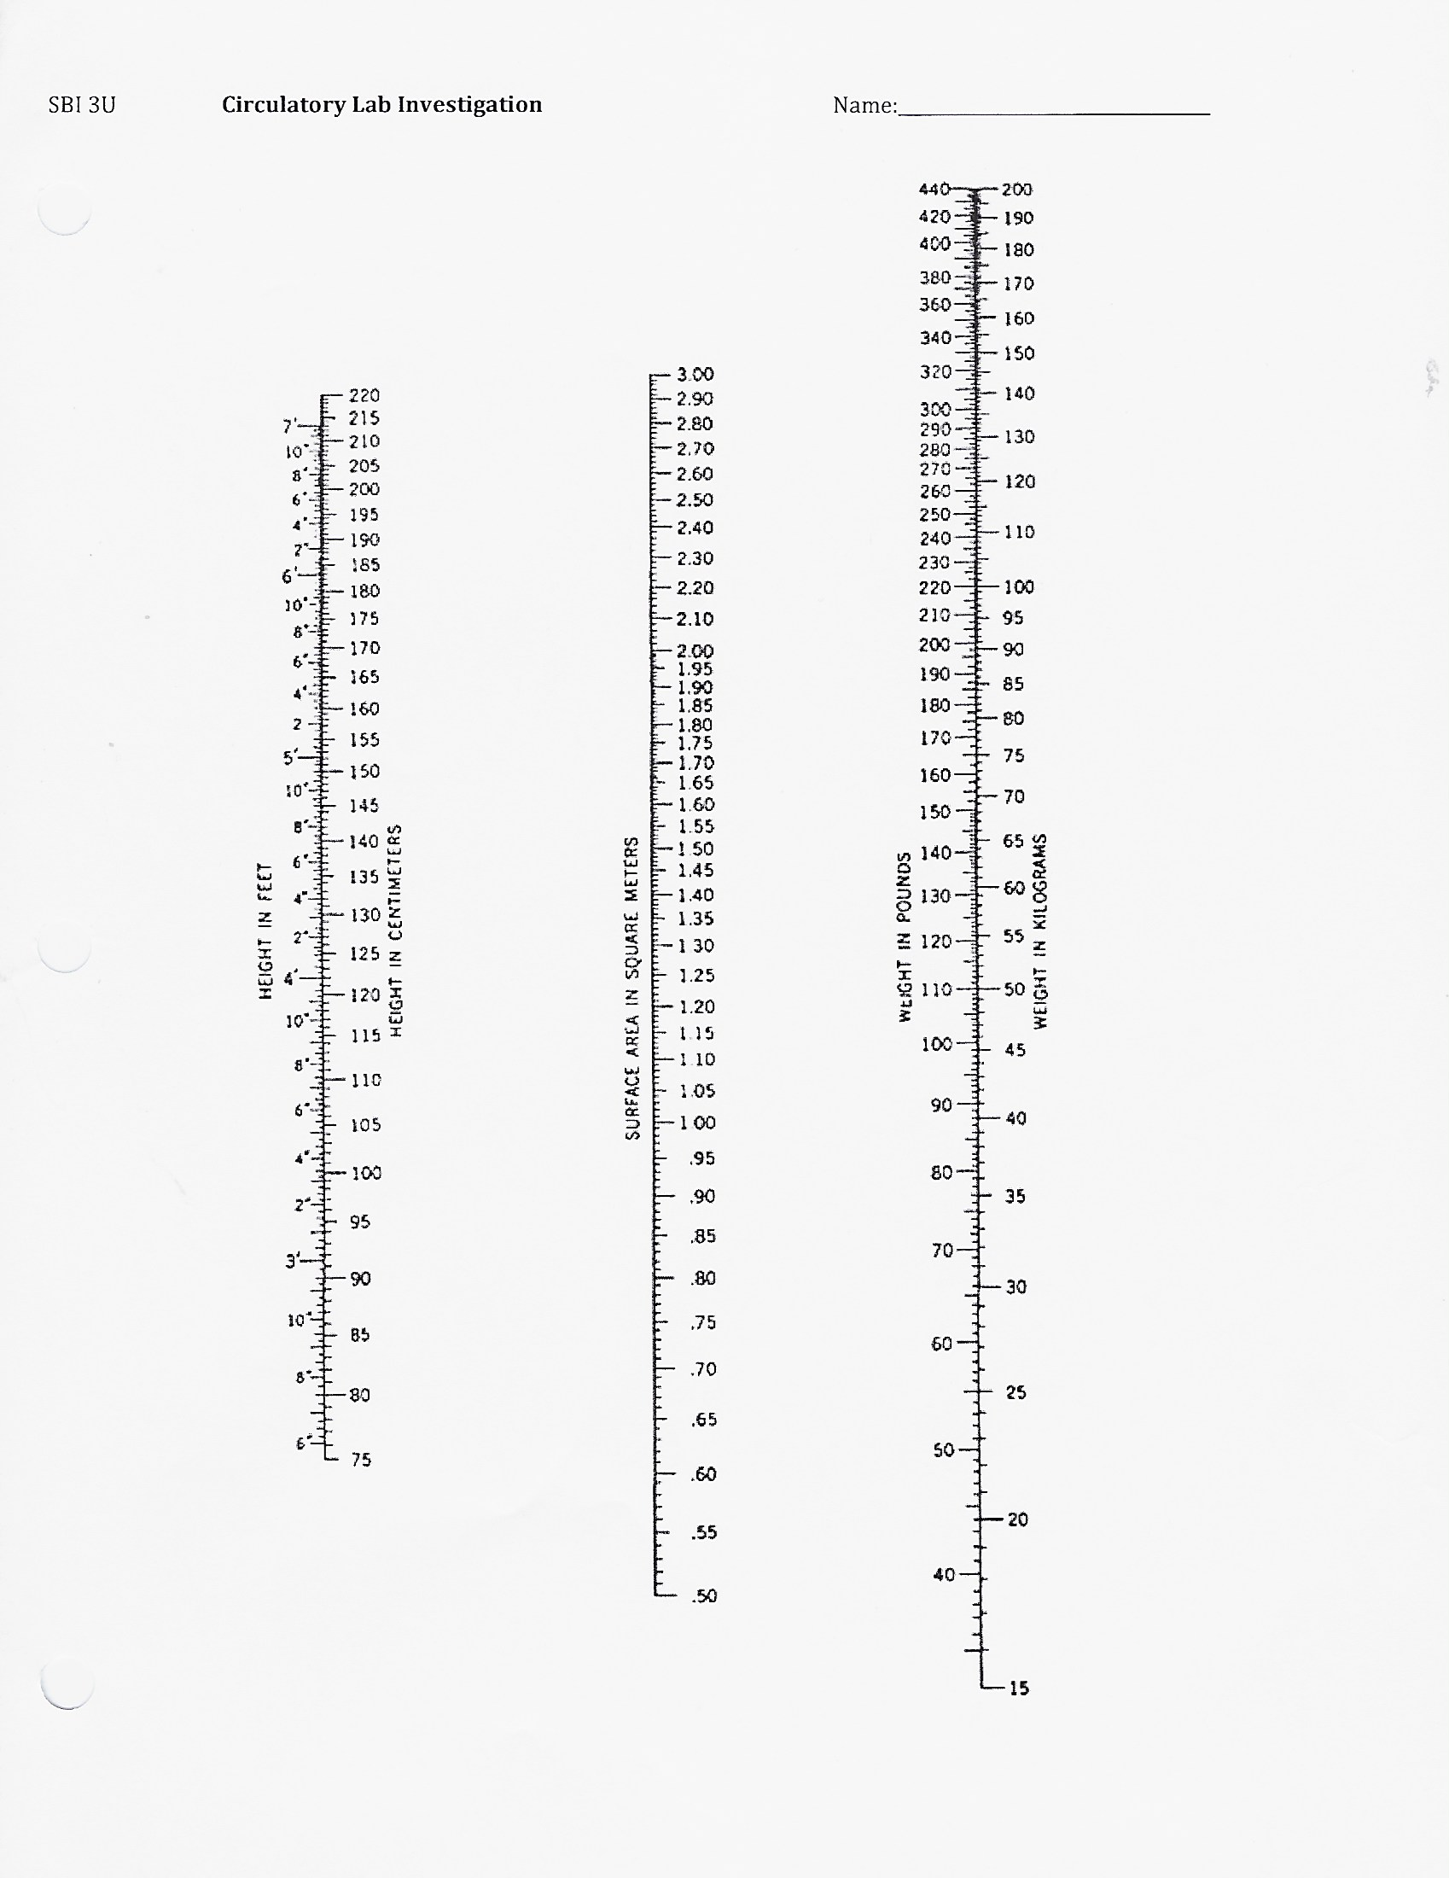
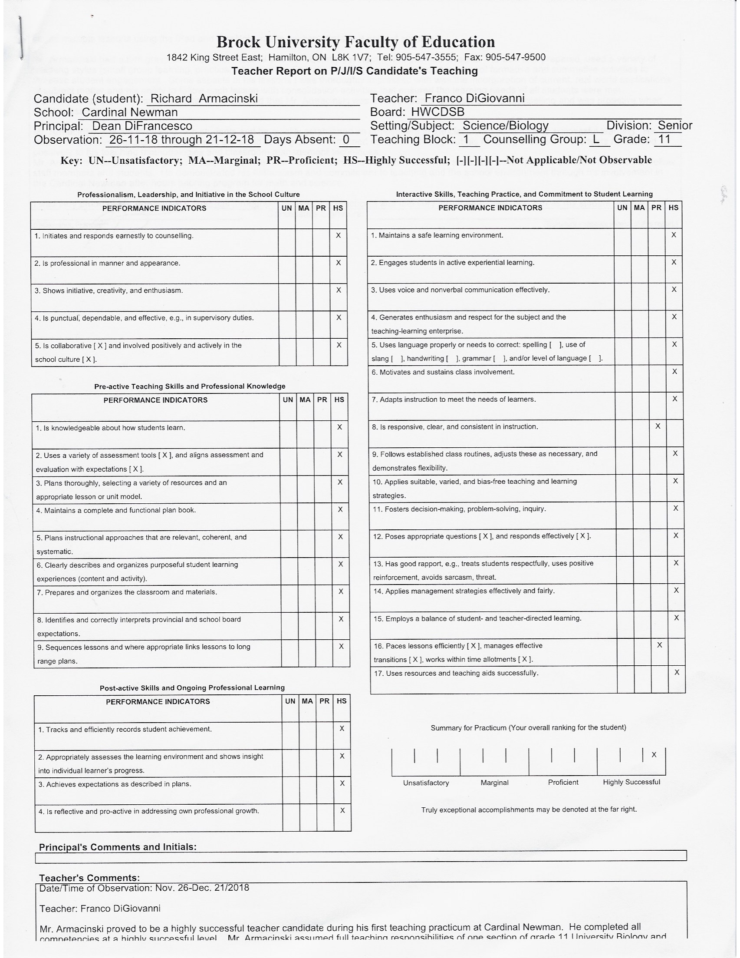
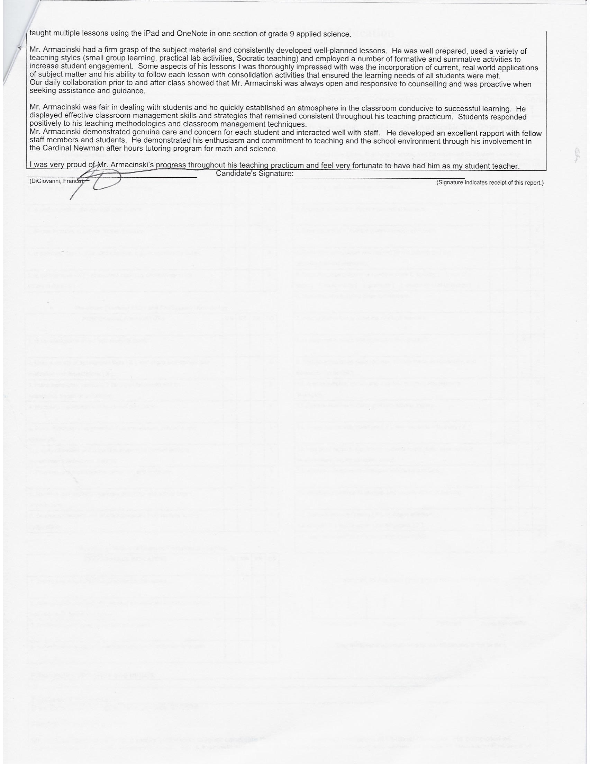
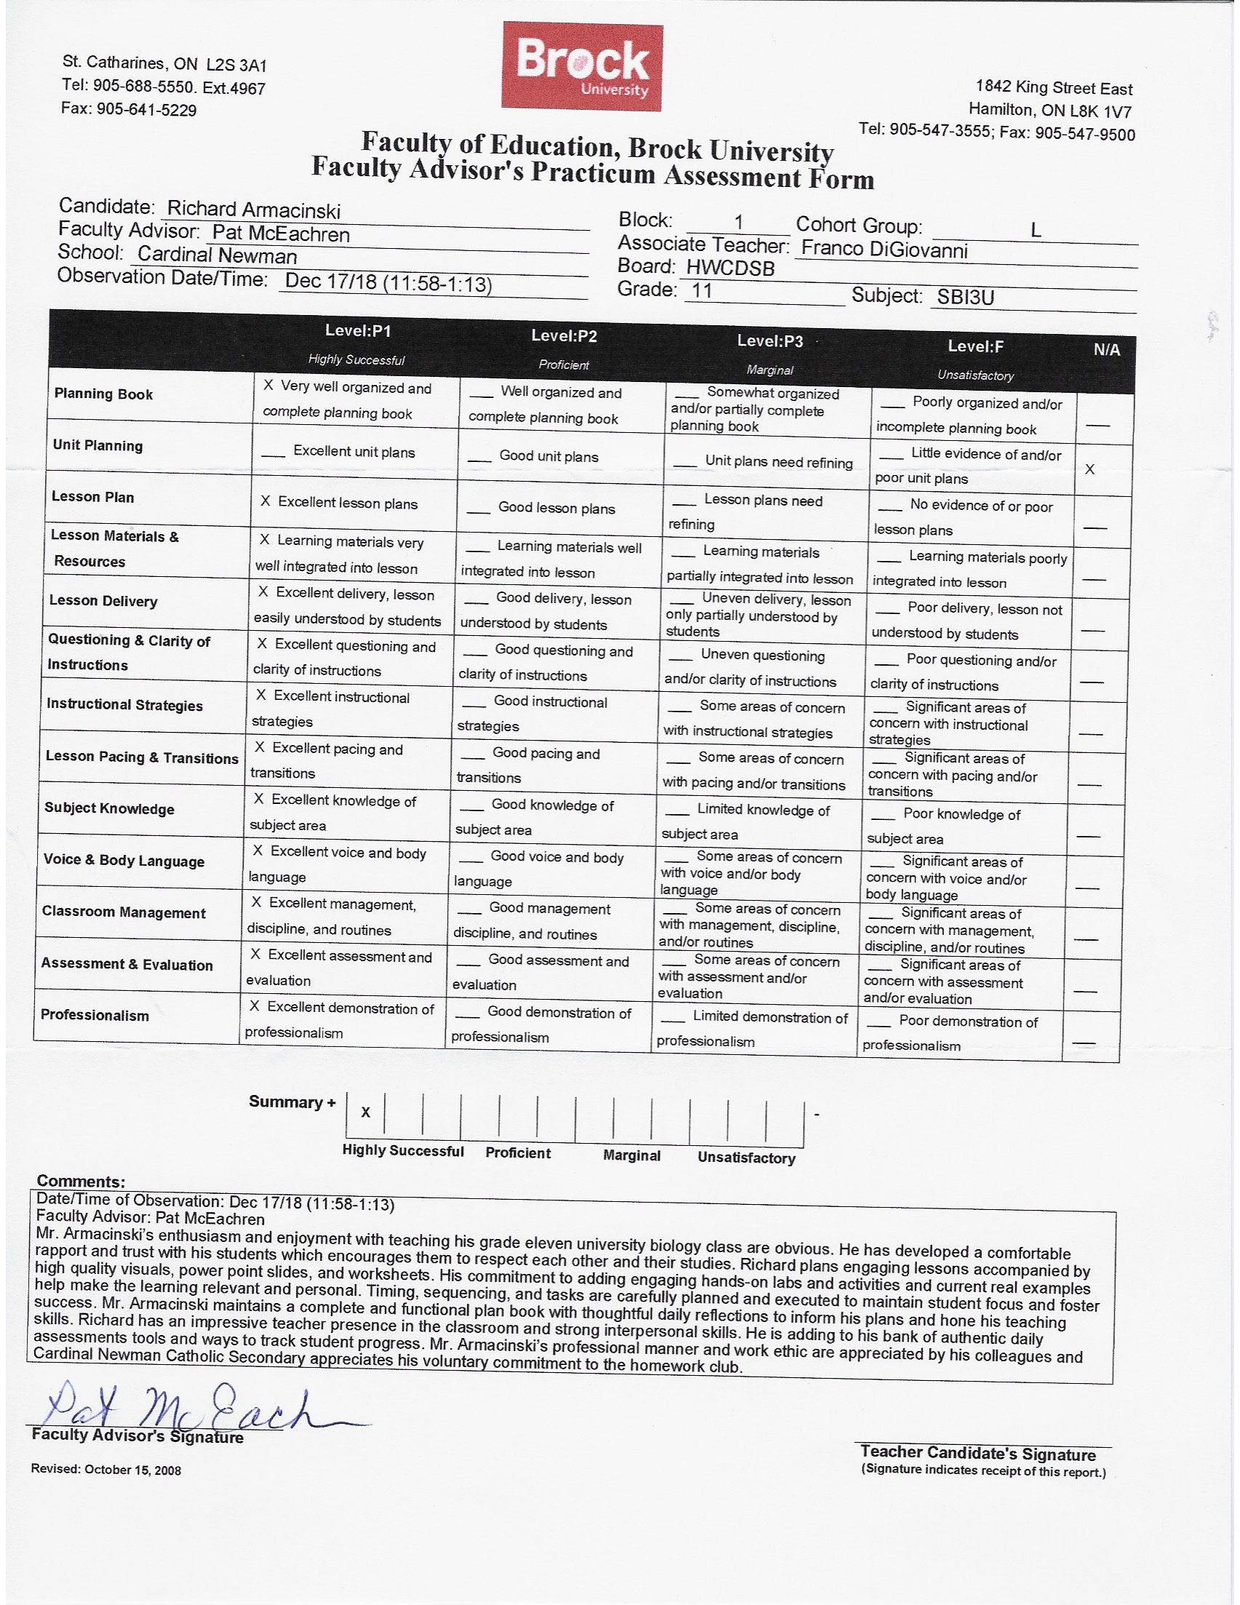
RICHARD ARMACINSKI
22 Vogue Court, Stoney Creek, ON L8E 4T3
Phone: 905-643-7056 Email: richard.armacinski@sympatico.ca

EDUCATION & CERTIFICATIONS
Registered Member, Ontario College of Teachers (OCT # 694619) May 2019

Bachelor of Education, Intermediate/Senior Qualification May 2019
Brock University, Hamilton, ON
Bachelor of Science (Honours) (Biology Major, French teachable) - First Class Standing Jun 2018 Brock University, St. Catharines, ON

HWDSB - Grade 8 International Language Program - Fluent in Polish Jun 2010

ADDITIONAL COURSES
- Religious Education (Catholic) Mar 2019
- École de langues de l'Université Laval Jul 2016 Université Laval, Québec City, Québec
- École de langues de l'Université de Montréal Jul 2014 Université de Montréal, Montréal, Québec
- French Level I-III 2012-2014
Collège Boréal, Hamilton, Ontario
- Royal Conservatory of Music 2008-present
Grade 9 Piano/Grade II Theory with First Class Honours with Distinction

CLASSROOM EXPERIENCE
Student Teacher, Grade 11, Cardinal Newman Catholic Secondary School, Stoney Creek, ON Nov 2018 - Dec 2018
- Designed, planned and implemented educational lessons within the grade 11 university biological curriculum to institute critical thinking within the systems structures and function unit
- Utilized a differentiated approach whereby the needs of Visual, Auditory, Reading, Writing and Kinesthetic
learners were all met through a variety of labs and activities
- Implemented a 21st century classroom setting with the use of various technologies such as Kahoot to foster the
minds of digital learners and receive constant diagnostic feedback from the students
- Participated in the afterschool homework club tutoring students in Biology, Math and Chemistry
- Achieved a “highly successful” rating from both the faculty advisor as well as the associate teacher

Oxford Learning Centre, Stoney Creek, ON 2017 - present
- Tutored students, grades 1 to 12, in small groups of 2 to 3, in French, Mathematics, the Sciences, and English.
- Made sure students were confident in their abilities before moving on to the next concept.

HWCDSB Home Grown Math Success Tutor, Online Tutor (Work at home) 2018
- Worked to send supportive messages to parents about progress and troubleshooting when using the SuccessMaker math game.
- Created progress reports and gathered data on student progress.

Les Petites Pommes, French Soccer Teacher, Jewish Synagogue, 215 Cline St. Hamilton, ON Aug 2015-2018
- Played an active coaching role in allowing students to grow within their French vocabulary and soccer skills
- Differentiated various drills and activities throughout the camp based on the students’ soccer and language ability allowing each child to be successful

Summer Literacy Program, St. John the Baptist (Aug 2015, Aug 2016), Holy Name of Jesus School (Aug 2014)
- Planned and taught physical literacy activities and utilized the computer program Lexia with students to facilitate learning in a classroom setting
- Created a welcoming classroom community and served as a facilitator during recess

HWCDSB Tutor in the Classroom Program, HWCDSB Closing the Gap Tutor Grade 2-6
St. Francis Xavier Catholic School & St. David’s Catholic School, Stoney Creek, ON Sep 2016 – Jun 2018
- Tutored and provided one-to-one math sessions within grade 3-6 classes twice weekly
- Closed the achievement gap of students in grades 3-6, overall student marks increased from level 2 to 3 based on an EQAO diagnostic test as well as Nelson PRIME diagnostic testing
Special Needs Tutor, St. Charles Centre, St. Thomas More Catholic Secondary School, Hamilton, ON July 2015-2017
- Consulted one on one with students who required additional assistance within the summer school program
- Delivered tutoring services in all math classes as needed once all commitments with special needs children was completed
- Developed and implemented programs working with students with a range of exceptionalities as identified by the Ministry of Education

Student Teacher, Grade 7-8 Hillcrest Elementary School, Hamilton, ON Sep 2015 – Apr 2016
- Supported grade 8 classroom teacher in delivering Ontario science and math curriculum to students in grade 8
- Participated in the afterschool tutoring program mentoring small groups of students with mathematical lessons

TEACHING RELATED EXPERIENCE
PISK- executive member planning Polish centred events and connecting with professionals 2019-present
Homework Club: Cardinal Newman Catholic Secondary School, Stoney Creek, ON Nov-Dec 2018
HWCDSB Robotics Tournament / Science Fair / Chess Tournament Judge 2016, 2017
Lecturer: St. Francis Xavier and St. Stanislaus Parishes Sep 2011 – Present
Mentor: Brock-Niagara French Contest May 2015
Les Petites Pommes French Summer Camp Instructor, Hamilton, ON Aug 2015-2018 Brock University French Club, St. Catharines, ON 2014-2018
Peer Leader: City of Hamilton - Public Health Services, Hamilton, ON Dec 2010 – 2014 Soccer Coach – Saltfleet Soccer Club, Stoney Creek, ON 2005-2007

PROFESSIONAL WORKSHOPS
- Affiliates’ Day Jan 2019
- Building Futures – A Day with the Ministry of Education Oct 2018
- Makerspace Oct 2018
- Ontario Teachers’ Federation (OTF) Professional Boundaries Workshop Oct 2018
- safeTALK suicide alertness training 2013

CERTIFICATES
- Workplace Hazardous Materials Information System Training 2018
- Standard First Aid – CPR /AED Certified, Red Cross May 2014 – May 2017

AWARDS
Brock University Dean’s Honour List, 2014 - 2018

Brock Scholars Award - Academic Brock University Scholarship, 2014 - 2018
Brock University Science and Math Excellence Award, 2014 - 2018

Brock University Academic Excellence Award, 2014
Golden Key International Honour Society - Top 15% in faculty of study, 2014- 2018
Lieutenant Governor’s Award, 2014
Award for Academic Excellence – Top Standing Student, 2014
Dr. Angelo Frisina Chiropractic Award – Math & Science, 2014
The Optimist Club Award for Volunteering Excellence, 2014
Stoney Creek Chamber of Commerce Volunteer Distinction, 2014
The Hamilton Spectator Youth Volunteer of the Year Finalist, 2013, 2014
University of Toronto National Scholarship Program for academic performance, original & creative thought and
exceptional achievement in a broad context, 2014

REFERENCES

Dr. Lorenzo Cherubini Mrs. Patricia McEachren Mr. Adrian DeTullio, Principal
Professor, Faculty of Education Cohort Teacher, Faculty of Education St. Luke CES
Brock University Brock University 905-561-3966
905 547-3555, ext. 3603 905-688-5550 detullioa@hwcdsb.ca
lcherubini@brocku.ca pmceachren@brocku.ca

Richard Armacinski 22 Vogue Court ▪ Stoney Creek, ON L8E 4T3
(905) 643-7056 ▪ richard.armacinski@sympatico.ca

March 18, 2019

Senior Science Faculty Member

RE: Don Galbraith Preservice Teacher Award of Excellence

To Whom It May Concern,

Please consider this letter, copy of my Associate Practicum Evaluation for science teaching during Block 1 and the attached current copy of my résumé as an expression of interest in the Don Galbraith Preservice Teacher Award of Excellence. I am currently completing my Bachelor of Education in the Intermediate/Senior Program at Brock University with teachable subjects in Biology and French. Through my classroom experience and desire to provide students with creative science preparation and teaching, I feel that I would demonstrate the criteria for selection within this particular award.

My teaching pedagogy focuses on generating student success by designing a safe and inclusive 21st century learning environment. Being a digital native, I have an understanding of the needs of modern students. Teaching grade 9 science and grade 11 Biology at Cardinal Newman Catholic Secondary School allowed me to implement various technologies within the courses. I used Kahoot’s, interactive online lab demonstrations and note taking with OneNote on iPads, which aided in obtaining a variety of diagnostic assessments of student comprehension. I put students at the centre of their learning by balancing instruction and inquiry. I targeted all learning styles (visual, auditory, kinesthetic), and ensured that students were equipped both academically and socially with global competencies that are necessary in the 21st century. It is important to create a classroom where students can be critical thinkers and enjoy the learning process because they are intrinsically motivated to do their best.

I am committed to volunteering with students in order to sustain a successful science-learning milieu for all. I assisted students in the After-School Tutoring Program (at Cardinal Newman high school) to further enrich an understanding of science concepts. I also served as a judge at the Annual Bishop Ryan Science and Engineering Fair and FIRST Lego League Tournament in further developing students’ appreciation of science and encouraging scientific exploration.

I am passionate about differentiating instructional methods within my imminent science classroom. I welcome every educational opportunity to further pursue my goals in being the best and most effective science teacher. Moreover, by being awarded with a 3-year membership in STAO/APSO, I feel that I would obtain the most up to date resources available to make my classroom environment stimulating for the 21st century learner.

Sincerely yours in education,
Richard Armacinski

