STAO Online Safety Mindedness Elementary Users Guide
The STAO on-line Safety Mindedness Resource is a fairly intuitive-to-use safety professional learning tool about delivering a hands-on science and technology program. It should be able to help teachers, consultants, principals and teacher candidates in their planning and delivery of a thoughtfully safe, effective and engaging hands on science and technology program.

Mechanics of using the STAO Safety Mindedness online resource:

Completing the whole resource thoughtfully should take about 7-9 hours of on task time. It is quite appropriate to not do the whole safety resource in one session but spread it out over whatever time you feel is appropriate to your professional needs.

If time is a constraint, our suggestion is to make sure you do modules 2 and 3 as a first priority (required for minimum due diligence) because they will help you thoughtfully decide what hands-on activities are doable for your classroom and which are
potentially too hazardous as currently planned or present too much risk compared to potential learning.

When accessing the resource try to also have a copy of STAO’s ‘Safety in Elementary S&T, a reference guide for Elementary School Educators’ available. It has further in-depth lists and suggestion for various components of an engaging science and technology program and classroom. It includes authoritative safety information on plants and animals, tools and materials, equipment and safety protocols to help you make informed choices for your programs.

To access the Elementary Safety Mindedness online resource click on https://stao.ca/cms/safety-mindedness

Organization

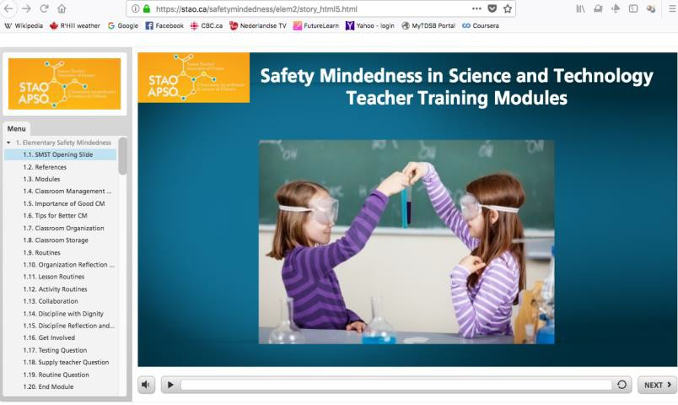The screen is divided into an interactive sidebar chapter display on the left, which is clickable, and allows you to move back and forth through the modules at will (much like the Adobe Reader for PDF documents).

The training will start as soon as you open the link. Listen to and watch the commentary from the expert experienced teacher with the wonderful voice. When the commentary is completed, either click the “next” button to move on, follow the instructions on screen or replay the video. The videos that are shown here can be stopped and started and replayed at will.

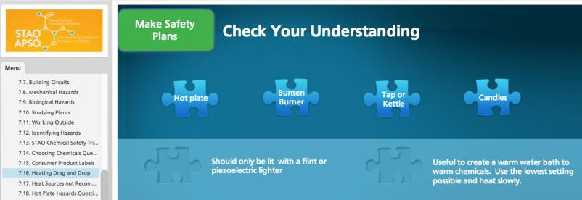The main display screen can be interactive when a response or an action such as moving objects around is required.

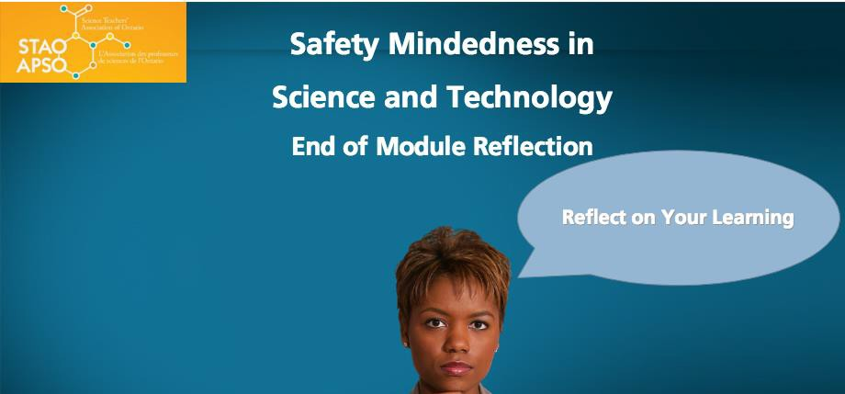Reflective questions are your opportunity to think, and if possible, pair and share what you have learned or experiences that you have that could be discussed with colleagues.

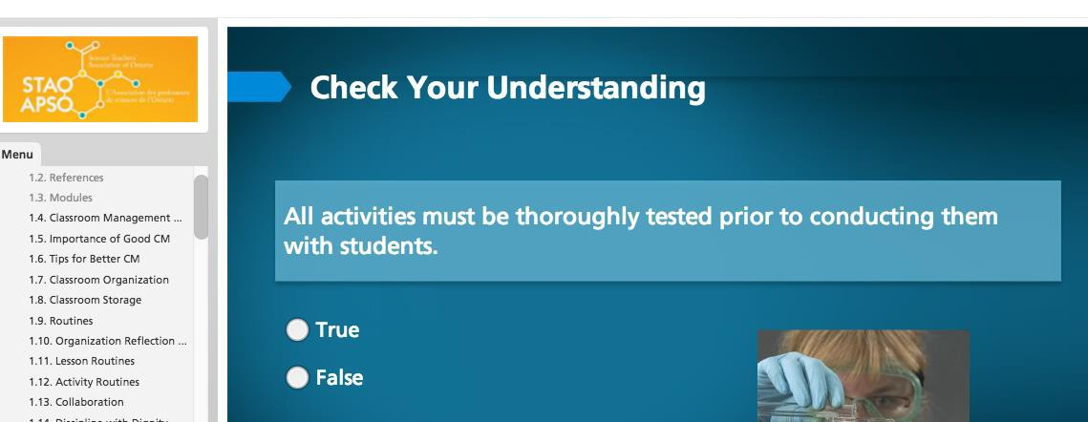The quizzes that are interjected throughout the modules are intended to be a self evaluative learning tool and not a pass/fail instrument. The quizzes sometimes require more than one response and are expecting you to be very discerning.

Suggested approaches for learning from the Safety Mindedness online resource:

Individual
- Familiarize with resource by reading “Mechanics of using the Safety Mindedness online resource”
- If you can only do some of the resource due to time constraints, complete Module 1.1 1.2 and all of Modules 2 and 3 as these are the most important elements of the safety training in one session.
- If committing to completing over a longer period of time, such as part of an action or annual learning plan, complete each module in the order they appear.

Local Pair or Triad
- One of the participants familiarizes with the resource by reading ‘Mechanics of using the Safety Mindedness online resource’, while other participants have refreshments/bathroom break, and helps other participants with orientation and navigation on return.
- If you can only do some of the resource due to time constraints, complete Module 1.1 1.2 and all of Modules 2 and 3 as these are the most important elements of the safety training in one session.
- The modules could be completed by working on a single shared IT device or with an IT device hooked up to a projector and sound system.
- If committing to completing over a longer period of time, such as part of an action or annual learning plan, complete each module in the order they appear.

At a distance, pair or triad
- Each participant familiarizes with resource by reading “Mechanics of using the Safety Mindedness online resource”
- If you can only do some of the resource due to time constraints, complete Module 1.1 1.2 and all of Modules 2 and 3 as these are the most important elements of the safety training in one session.
- Remote access sharing ideas: Google Applications for Education (GAFE) products such as Hangout and a drive shared documents could be used to complete reflective and clarifying questions at the same time. Each person would then follow the Safety Mindedness resource within an allocated period of time.
- If committing to completing over a longer period of time, such as part of an action or annual learning plan, complete each module in the order they appear.

Suggested timelines for completing the Safety Mindedness online resource

  - Intro 1.1 and 1.2 (5 min)
○ module 1-1 to 1-20 (~35 min)
  - module 2-1 to 2-15 (~35 min) plus participant discussion if pair or triad
  - module 3-1 to 3-9 (~25 min) plus participant discussion if pair or triad
○ Module 4-1 to 4-23 (~60 min)
  - Module 5-1 to 5-8 (~15 min)
  - Module 6-1 to 6-10 (~15 min) may also have been completed as part of OH&S workplace compliance training, self assess by scanning slides and questions.
○ Module 7-1 to 7-25 (~60-90 min)
  - Module 8-1 to 8-8 (~20 min)

Overview of the STAO Elementary Safety Mindedness Training Resource: Each module contains short videos, images, reflective questions, and assessments to inform and engage teachers. Use these modules individually or in groups to broaden your safety mindedness.

Module | Content | Reflective Questions | Assessments
1 - Classroom Management | Hints and suggestions for effective classroom management, considered to | - - Routines  - Introduce routines in a creative way? | 1.17 - All activities should be thoroughly tested prior to conducting them with students. (True or False)

40 min | be critical if teachers are to provide students with a safe environment for hands-on activities, are included in this module. | - - Classroom Organization  - How do routines and organization reinforce each other?  - What other challenges could present, i.e. shared classroom  - - Collaboration  - Share 2 powerful classroom strategies you have learned through PD or conferences  - - Discipline with Dignity  - Past discipline related to scenarios, how solved?  - - Discipline  - Avoiding confrontations  1.20 - Module reflection question | - - It is appropriate to leave activities involving chemicals or equipment to an experienced supply teacher. (True or False)  - - Which of the following are necessary when establishing routines?  - Start early in the course  - Model the safety behaviour you expect of your students  - Practice and reinforce routines until they are automatic  - Be consistent  - All of the above
2 - Identifying Hazards  35 min | This module is organized according to the five steps of STAO’s Safety Planning Framework:  - Identify the Hazards  - Assess the Risks  - Make Safety Plans  - Act Safely  - Reflect, Revise, and Report  specific examples of planning and carrying out | - - Three approaches to hands on activities in class  - Advantages  - Disadvantages  - - Organizing Activities  - Whose responsibility is it to ensure good housekeeping?  - - Know your Students  - Training needed to safely do pictured activity | - - Which can be controlled?  - hazard  - risk  - - Learning centre MC hazard question

 | some of the hands-on activities and teacher demonstrations while minimizing risk for all of their students. | - - Planning  - Importance of pre-testing activities before using in class  2.15 - module reflection question
3 - Assess the Risks  20 min | This module is organized according to the five steps of STAO’s Safety Planning Framework:  - Identify the Hazards  - Assess the Risks  - Make Safety Plans  - Act Safely  - Reflect, Revise, and Report  specific examples of what is involved in planning and carrying out some of the hands-on activities and teacher demonstrations. | - - Risk: Things to Consider  - Choose an activity that you do. What are the hazards? What controls do you put in place to minimize risks? Are these controls adequate?  3.9 - module reflection question | - - MC understanding check  - - TF understanding check  - - TF understanding check  - - MC understanding check  - 2 correct answers  - - MC understanding check  - 2 correct answers
4 - Safer Activities for All  50-60 min  In addition, there are videos linked to the following modules: | This module encourages teachers to adopt best practices to engage the wide range of learners, including those with special education needs, in hands- on activities.  These practices help make hands-on activities more inclusive for all students regardless of their learning | - - Roles and responsibilities  - Teachers, students and parents  - - Planning for Inclusive Activities  - What are some of the social benefits that may arise from making activities more inclusive?  - - Know Your Students  - Ministry Policy on preventing | - - MC ELL understanding check  - - MC ADD understanding check  - - TF IEP understanding check  - - MC Hands on understanding check  - - TF Special Ed understanding check

● 4.13 - 15  minutes  ● 4.14 - 14  minutes | needs. For example, some sample accommodations for English Language Learners are illustrated. | cultural and gender discrimination alternate activity considerations  - - Technology  - Provide a specific example of the use of technology as an accommodation.  - - Specific Strategies  - Wheel chair accessibility classroom modification  4.22 - Module reflection question
5 - Safety Planning: PPE  15 min | This module is organized according to the five steps of STAO’s Safety Planning Framework:  - Identify the Hazards  - Assess the Risks  - Make Safety Plans  - Act Safely  - Reflect, Revise, and Report  The fundamental approach to this module is controlling the hazards in activities so as to keep their risk to an acceptable level. | - - Eye Protection  - Why should everyone in the room continue to wear eye protection until the last student has finished the activity?  - - Goggle Storage  - If your students share eye protection, what process do you have in place to ensure it is cleaned properly?  5.8 - Module reflection question | - - Eye Protection, drag and drop activity  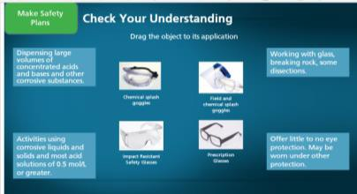  - - MC vision PPE understanding check  - - TF vision PPE understanding check  - - MC vision PPE understanding check
6 - Safety Planning: Policies and Standards | This module is organized according to the five steps of STAO’s Safety Planning Framework: | - - Standards  - What additional safety resources are available in your school or board? | - - MC Safety data sheet understanding check  - - MC Safety data sheet understanding check

15 min | - Identify the Hazards  - Assess the Risks  - Make Safety Plans  - Act Safely  - Reflect, Revise, and Report  This section may have been substantially covered and understood through board supplied Occupational Health and Safety compliance training. | - Who is the health and safety lead for your board?  6.11 - Module reflection question | - - MC Safety data sheet understanding check  - - TF WHMIS pictogram understanding check  - - Pictogram practice (matching terms with pictures)  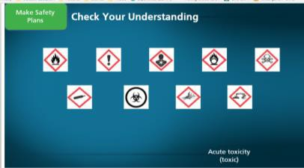  - - Fill in the blank WHMIS 2015 divides hazards into two categories, physical and  .  - - What feature do WHMIS 2015 supplier labels have that MSDS labels did not?  - Supplier identifier  - Signal word  - Hazard pictogram  - Precautionary statements
7 - Safety Planning: Types of Hazards  20-60 min depending on grade taught, specimens considered, materials and | This module is organized according to the five steps of STAO’s Safety Planning Framework:  - Identify the Hazards  - Assess the Risks  - Make Safety Plans  - Act Safely  - Reflect, Revise, and Report | 7.7 - Building Circuits  What best practices do you use to ensure circuit activities remain safe and effective? What challenges remain?  7.12 working with plants and animals identify probable or suspect hazards and board policies.  7.25 - Module reflection question | - - match items safety triangle  - MC chemicals understanding check  - - matching HHPS symbols exercise for understanding check  - - matching heating types exercise for understanding check  - - identify heating sources not approved for

tools/technolo gies used. | Teachers are provided with specific examples of what is involved in planning and carrying out some of the hands-on activities and suggestions for doing them as safely as possible. | use understanding check  - - MC hot plates understanding check  - and 20 - TF batteries understanding checks  - MC electrical cords understanding check  - MC live animals understanding check  - TF live animals understanding check  - MC field trip understanding check
8 - Act Safely 15-20 min | This module reviews and provides thoughtful ideas on how to assess, reflect and revise safety protocols in your classroom and board. | - - Reflect, Revise, and Report  - What is the process of reporting classroom accidents in your school?  8.11 - Module reflection question

