SNC 4E: Hazards in the Workplace

Teacher Demo/Student Activity: Powder Disaster
Topics  Harmful workplace practices  Factors that affect safe storage and disposal of chemicals | Timing  preparation: 5 minutes  demonstration/activity: 10-15 minutes

Specific Expectations SNC4E

Introduction
Flour is an ingredient that is found in most kitchens and used regularly for baking and cooking. Consequently, it is considered safe, and people do not regard the potential hazards. In reality, flour and dust explosions are extremely dangerous, and reducing the risk of such an explosion is a major concern to the agriculture and food processing industries.

The purpose of this demonstration/activity is to illustrate the importance of being aware of potentially harmful situations and practices in the workplace. In particular the dustiness of a material can affect the nature of chemical reaction, affecting a safe working environment.

Materials
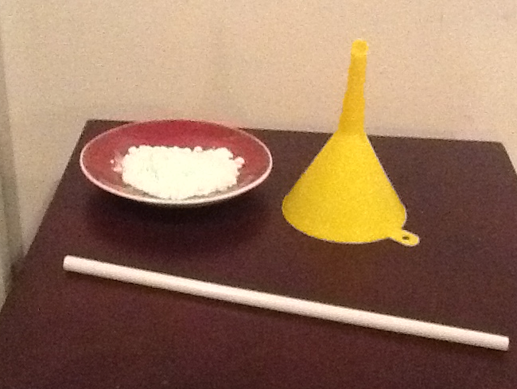
Bunsen burner
Spark igniter or matches
1 watch glass of small plastic funnel
1 bendable plastic straw or tubing
Approximately 15 mL measure of refined flour
Wooden splint
Safety goggles

Safety Considerations
Wear safety goggles and gloves. Do this demonstration in a fume hood to isolate the flour from the class. Flour used for science may be contaminated by other materials and cannot be ingested as food.

Ideally, this demonstration should be performed in a can with an exhaust hose. See Additional Resources #3 for an example of this method.

Review fire safety procedures.

Procedure
Preparation
- Set up a Bunsen burner in the fume hood.
- On a watch glass have a small amount of flour. Make sure the flour is settled before starting the lesson. There should be no airborne flour.

Minds On
- Organize the class into pairs. Ask each pair to describe flour from their past experience and their observations of the sample in class.
- Also ask each pair to describe any hazards related to the storage or use of flour.
- Invite students to share their thinking with others in the class.
Predict/Explain
- Explain to the class that you are going to add flour to the flame of a Bunsen burner
- Ask pairs to brainstorm ways to add flour to the flame.
- Ask pairs to think about this and draw a diagram of what this will look like at the flame.
- Ask pairs to record their thoughts about what will happen and why they think this will happen.
Observation:
- Explain the two ways flour is introduced to a flame:
- a flame is moved near the flour
- airborne flour is blown onto the flame
- Ask students to observe the demonstration as it progresses.
- Invite students to ask questions so that they are clear about what they will see.
- Ignite the Bunsen burner.
- Ignite a wooden splint from the burner and move the splint near the flour in the watch glass.
- Move the flame away.
- Use a long bendable straw or tubing to blow the flour from the watch glass into the flame.
Observe
- Ask students to describe what they observed.
- Ask students to share their observations with their partner.
Explain
- Once everyone has a clear description of what happened, as the pairs to explain why airborne flour created a fireball but the flour sitting still did not ignite.

Disposal
The flour can be disposed of in the regular garbage or municipal organic waste if available.

What happens?
Flour ignites to form a fireball when fine dust particles are blown into the flame, and not when in the flour is sitting in a stable pile on the watch glass.

How does it work?
Flour is combustible. When sitting as a stable pile the fuel (flour) is more connected to other flour particles than oxygen particles. As dust, each dust particle is surrounded by oxygen particles. This supports the combustion of the flour particle. As each particle moves through the flame, the combustion moves with the particles. Flour explosions tend to be connected to the movement of flour through air. The source of ignition is often discovered to be a static discharge.

Teaching Suggestions/Hints
- Ensure you practice this demonstration prior to performing it with a class.
- You may prefer to add flour to a small funnel that is attached to a tube. Blow through this tube to spray the flour over the flame.
- Cornstarch and sugar are similar materials that produce similar results.

Next Steps
This demonstration can be used to introduce the concept of potentially harmful situations and practices in the workplace that demand attention to proper procedure. Research into real events that are the result of food dust explosions will reinforce this message.
Students can consider the impact of other factors such as concentration, temperature and the materials chosen as structures that hold the combustible material.

Additional Resources
- Wired Magazine article: http://www.wired.com/wiredscience/2008/03/the-explosive-t/
- Scientific American Blog with article and video: http://blogs.scientificamerican.com/observations/2012/04/19/slow-motion-mayhem-video-sets-flour-aflame-video/
- A different method that illustrates the same concept: http://www.ece.rochester.edu/~jones/demos/dust.html
- The instructor uses corn starch in a model building: https://www.youtube.com/watch?v=IHDFDO7YOgM
- Science club students without Personal Protective Equipment, showing the method with the funnel: https://www.youtube.com/watch?v=s0sdvLYHua4

Specific Expectations
SNC4E
A1.1 formulate relevant scientific questions about observed relationships, ideas, problems, or issues, make informed predictions, and/or formulate educated hypotheses to focus inquiries or research
B3.4 identify common chemical hazards in the workplace (e.g., oxidizers, acid and base solutions), and describe potentially harmful situations and practices (e.g., inadequate venting of fine dust particles in flour mills) as well as best safety practices (e.g., wearing goggles and a self-contained breathing apparatus when working near substances that can irritate the eyes or lungs) relating to these hazards
B3.6 explain qualitatively how factors such as temperature, concentration, and the size of the opening of a container affect storage and disposal of chemicals in the workplace

Return to the top

