Canadian Mining in Peru and around the World
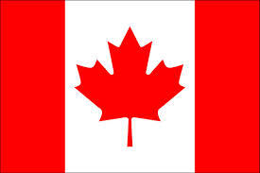
- There are over 100 Canadian mining companies operating in Peru.
- 75% of the world’s mining companies are based in Canada.
- The Canadian government gives money to mining companies and foreign governments to build infrastructure for local people and to make mining easier.
- Sometimes this can be good; it can also be bad.

Good  - Mining is necessary for us to get the minerals we need like copper, gold, and iron.  - It can be good for the economy and help to build infrastructure (roads, bridges, schools, hospitals, etc.) in foreign countries.  - Mining can create jobs in countries where jobs are hard to find.  - Doing business with other countries helps to create strong relationships. | Bad  - Mining has terrible effects on the environment and people’s health.  - Mining companies sometimes do not clean up their messes.  - The pollution caused by mining hurts plants, animals, and people.  - People in other countries who see Canadian mining companies polluting become angry at Canada.

What do you think we can do to solve this problem?
The minerals that come from mining are very interesting and useful. We have talked about their uses, their properties, and where they come from. We know that we need these minerals for all kinds of reasons. However, the process of getting them out of the earth can cause huge problems with plants, animals, people, and the environment.
As a group, come up with some ideas about how we can get the minerals we need but not hurt anyone or anything while mining for them.
Choose one of the ideas you have come up with and present it to the class in one of the following ways:
- A drawing
- A dance
- A dramatic representation (skit)
- A song
*Be prepared to explain your choice and your ideas.*

By Elijah Holt – 2014 Galbraith winner

